

**School of Computing and Engineering Sciences**

Bachelor of Science in Informatics and Computer Science

Bachelor of Science in Telecommunications

**ICS2104 / BTC2202: Computer Organization and Architecture**

**Assignment #2 Deadline:** **Wednesday 16th December 2020 @ 5:15 pm**



1. **Assignment Instructions:**



In this Assignment you are required to write a Java or C++ program to implement different **Number Systems** **Usage in Computer Systems** as opposed to the **human-friendly Decimal System**.*Note that there**complimentary information for support, namely: Ex. Notes of Computer Systems from UM – Sri Lanka and Ex. Representing Fractions using different Bases.*

1. **Assignment Requirements:**
   1. Write a Java or C++ program to generate the information in Columns 2 and 3, starting from the Decimal values and then automatically generating the Binary and Hexadecimal Numbers shown in Table Q1 (a).



**Table Q1 (a): Sample Conversion Information**

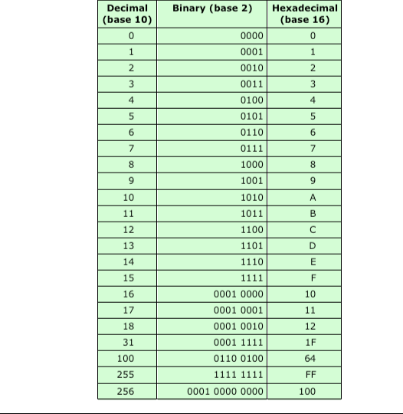

[**20 Marks**]



1. Write a program (Java or C++) to convert from decimal notation to binary notation for thirty (30) randomly generated floating-point numbers with at most three decimal points e.g., 123.875. Your result should give a list of randomly generated numbers, resulting binary notation and remarks column having



Assignment #2 – ICS2104: Computer Organization and Architecture School of Computing and Engineering Sciences, Strathmore University

Page 1

exactly or approximately (with at most five (5) decimal points) remark. Table Q1 (b) shows a sample of an expected results for 11.81 and 21.25 respectively.

**Table Q1 (b): Sample Appearance of Program Output**

|  |  |  |  |  |  |  |  |  |
| --- | --- | --- | --- | --- | --- | --- | --- | --- |
| **S/No.** |  |  | **Decimal Number** |  |  | **Binary Number** |  | **Remarks** |
| **1.** |  |  | 11.81 |  |  | 1011.01100 |  | Approximate |
| **2.** |  | 21.25 | |  | 10101.01 | |  | Exactly |

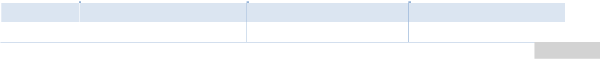

[**30 Marks**]

1. **Deliverables:**

3.1 Generate the result and copy and paste them in a Word for review using the documentation format provided.

3.2 Further – you will need to demonstrate to me or find a mechanism to prove that the program actually works J

1. **Documentation Instructions:**
   1. Group Composition and Report
      * Assignment Group can only have a maximum of four (4) students (but it can less J J)
      * Submission Report and respective code should be submitted through GitHub by sending me a link.
   2. Layout and Format.
      * Layout and format for assignment are defined in the BTC2202/ICS2014 Documentation Template.
   3. References and Citations
      * If you consult other references for the assignment(s), cite them using the APA style. Check out these URLs for guidance:
        1. http://www.library.cornell.edu/resrch/citmanage/apa
        2. http://www.apastyle.org/learn/tutorials/basics-tutorial.aspx



Assignment #2 – ICS2104: Computer Organization and Architecture

School of Computing and Engineering Sciences, Strathmore University Page 2